# Informações do estudo

Referência: Keblouti - coated insert

Grandeza: Força

Tipo: Fz

Material: AISI 52100

Ferramenta: GC 1525 coated insert

Número de experimentos: 27

Observações:  
Universal lathe SN 40C type  
Workpiece: round bars66 mm of diameter and 380 mm cutting length.  
Dynamometer: KISTLER Type 9257A  
Roughnessmeter: Surftest 201 Mitutoyo

# Unidades

Velocidade: m/min

Avanço: mm/rev

Profundidade de corte: mm

Força: N

# Dados de teste

|  |  |  |  |
| --- | --- | --- | --- |
| Força | n | f | a |
| 89.16 | 150.0 | 0.08 | 0.3 |
| 211.59 | 150.0 | 0.16 | 0.45 |
| 136.24 | 150.0 | 0.12 | 0.3 |
| 140.93 | 200.0 | 0.16 | 0.15 |
| 104.31 | 200.0 | 0.08 | 0.3 |
| 124.55 | 250.0 | 0.12 | 0.3 |

# Dados de treino

|  |  |  |  |
| --- | --- | --- | --- |
| Força | n | f | a |
| 187.13 | 150.0 | 0.12 | 0.45 |
| 129.35 | 150.0 | 0.08 | 0.45 |
| 148.13 | 150.0 | 0.16 | 0.3 |
| 149.46 | 200.0 | 0.16 | 0.3 |
| 138.0 | 250.0 | 0.08 | 0.45 |
| 78.3 | 200.0 | 0.08 | 0.15 |
| 122.98 | 250.0 | 0.08 | 0.3 |
| 220.28 | 250.0 | 0.16 | 0.45 |
| 212.82 | 200.0 | 0.16 | 0.45 |
| 118.49 | 200.0 | 0.12 | 0.3 |
| 112.92 | 250.0 | 0.12 | 0.15 |
| 103.67 | 200.0 | 0.08 | 0.45 |
| 147.2 | 250.0 | 0.16 | 0.3 |
| 120.49 | 200.0 | 0.12 | 0.15 |
| 117.65 | 150.0 | 0.12 | 0.15 |
| 164.3 | 250.0 | 0.12 | 0.45 |
| 92.37 | 150.0 | 0.08 | 0.15 |
| 69.76 | 250.0 | 0.08 | 0.15 |
| 161.24 | 200.0 | 0.12 | 0.45 |
| 137.54 | 150.0 | 0.16 | 0.15 |
| 127.92 | 250.0 | 0.16 | 0.15 |

# RN

Número de neurônios: 35

Taxa de aprendizado: 1.000000e-01

Número de épocas: 596

2° camada: False

Função de ativação: tanh

# Erros

**Dados de teste**

* Erro relativo médio: 7.93
* Coeficiente de correlação: 0.97
* Coeficiente de determinação: 0.94
* MSE: 132.14
* RMSE: 11.5

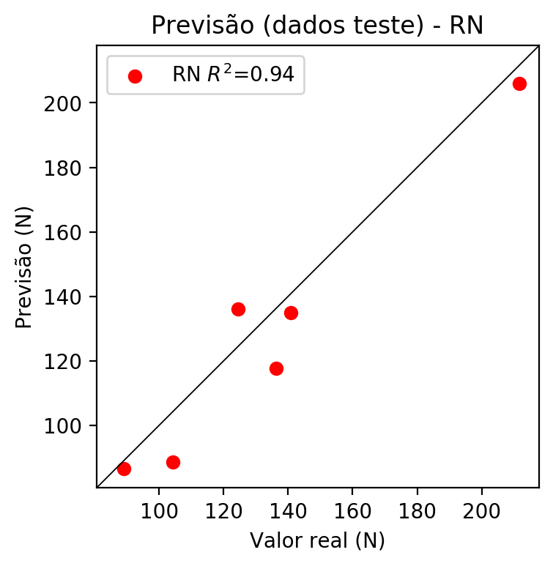

**Dados de treino**

* Erro relativo médio: 0.11
* Coeficiente de correlação: 1.0
* Coeficiente de determinação: 1.0
* MSE: 0.02
* RMSE: 0.14

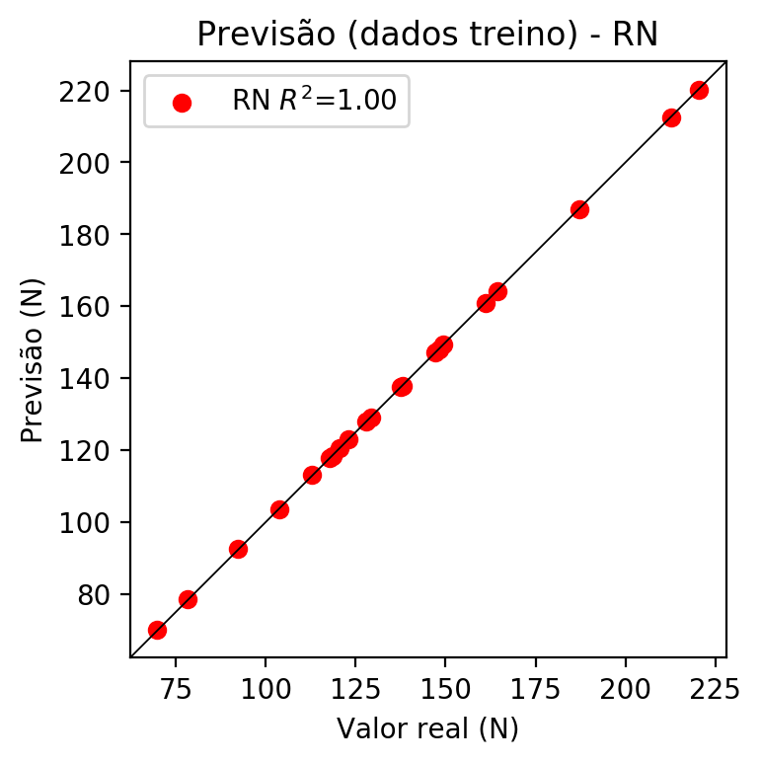

# Pesos

Pesos - camada oculta 1

[[-0.7997487 -0.5285816 0.60074353 0.02971712 -0.5390845 0.54498386  
 0.05832759 -0.6395183 0.73207945 -0.52941394 0.3749005 -0.2840557  
 -0.4010667 -0.15756558 0.80442995 0.72912216 -0.6017125 0.4154192  
 0.35981074 -0.38604406 -0.41598982 -0.46905366 -0.12461147 -0.86703175  
 0.9505841 0.4683531 -0.25877157 -0.8373892 -0.435097 0.46992126  
 0.6532698 0.30326632 0.299151 0.48135993 0.16123462]  
 [-0.05339924 0.38080272 -0.41537178 -0.17658493 0.66603196 -0.6270206  
 0.09859098 0.59607154 0.65961325 0.4025995 -0.63184136 0.44736758  
 0.38724345 0.48545653 -0.0836786 0.09567295 0.49482977 -0.3744703  
 -0.6898688 0.4285678 0.69096327 0.45635122 0.22819841 -0.04729794  
 -0.3457676 -0.40299395 0.25223377 -0.51563126 0.795503 -0.33296296  
 -1.2330612 -0.6988155 -0.20969811 -0.8191016 0.0640953 ]  
 [ 0.58984065 -0.46499613 -0.6062517 -0.28091276 0.76704216 -0.68196356  
 0.08443943 0.32783124 -0.42060304 -0.01837098 -0.1194092 -0.3472101  
 -1.412 -0.12128103 -0.39071757 0.43810657 -0.32661295 0.3495626  
 -0.9148502 0.91342264 0.56456107 -0.19799854 -1.6945148 0.53566206  
 -0.01097531 -0.81015784 -1.3327924 0.89755005 0.9331896 -0.79246765  
 0.31813344 -0.8313064 0.3450428 -0.74050117 -0.8986096 ]]

Bias - camada oculta

[-0.22395691 -0.07184651 -0.11655473 -0.5807773 0.46448642 -0.501624  
 0.622711 -0.503573 -0.30465177 -0.40971854 0.01949942 -0.30508277  
 0.8293874 0.75615174 0.17062652 -1.0599613 -0.08918712 0.07723391  
 0.10267662 0.04136764 0.2583503 -0.26122585 0.29421145 -0.1848044  
 0.57426095 -0.230046 0.43858853 -0.55526423 0.5258114 -0.15866253  
 -0.96855223 -0.07344637 -0.14986293 0.8846583 -0.41324428]

Pesos - camada saída

[[-0.2179314 0.05621395 0.14238311 -0.21205124 -0.13677913 0.08506449  
 0.07283935 0.39550757 0.2094317 0.16814023 0.03393633 0.02499371  
 -0.42907357 0.15715684 0.09892908 0.27816924 0.20049927 -0.04269889  
 0.00913024 -0.02201415 -0.09881055 0.01185466 -0.53313684 -0.18206558  
 -0.4125095 0.06306442 -0.381411 -0.2456057 -0.19334957 0.05287923  
 -0.69784766 0.07220162 0.02007469 -0.44177732 -0.33192623]]

# Iterações

|  |  |  |  |  |  |  |
| --- | --- | --- | --- | --- | --- | --- |
| Média | Desvio | n | ln | 2° camada | Função | Épocas |
| -0.2422 | 0.1617 | 10 | 0.1 | False | relu | 38 |
| -0.2762 | 0.2933 | 17 | 0.1 | True | relu | 716 |
| -0.3441 | 0.2586 | 7 | 0.01 | True | tanh | 130 |
| -0.3264 | 0.1288 | 19 | 0.001 | False | tanh | 282 |
| -0.3517 | 0.09 | 29 | 0.001 | False | relu | 469 |
| -0.3067 | 0.0964 | 88 | 0.1 | False | tanh | 926 |
| -0.3232 | 0.23 | 95 | 0.0001 | True | relu | 984 |
| -0.3245 | 0.3405 | 10 | 0.01 | True | tanh | 865 |
| -0.6461 | 0.56 | 58 | 0.001 | True | relu | 8 |
| -0.1862 | 0.1737 | 9 | 0.01 | False | tanh | 514 |
| -0.3092 | 0.171 | 73 | 0.0001 | True | relu | 729 |
| -0.4506 | 0.2807 | 22 | 0.001 | True | relu | 543 |
| -0.3977 | 0.2641 | 25 | 0.1 | True | relu | 562 |
| -0.289 | 0.1239 | 53 | 0.001 | False | relu | 498 |
| -0.3035 | 0.1524 | 83 | 0.01 | True | relu | 337 |
| -0.2883 | 0.1359 | 99 | 0.01 | False | tanh | 16 |
| -0.3285 | 0.1369 | 23 | 0.01 | False | relu | 472 |
| -0.2866 | 0.1951 | 24 | 0.001 | True | relu | 778 |
| -0.2673 | 0.1394 | 58 | 0.01 | True | tanh | 382 |
| -0.186 | 0.1015 | 35 | 0.1 | False | tanh | 596 |

# RL

# Coeficientes

[ 0. -0.01553081 0.6279457 0.61884271]

# Erros

**Dados de teste**

* Erro relativo médio: 7.29
* Coeficiente de correlação: 0.99
* Coeficiente de determinação: 0.97
* MSE: 128.19
* RMSE: 11.32

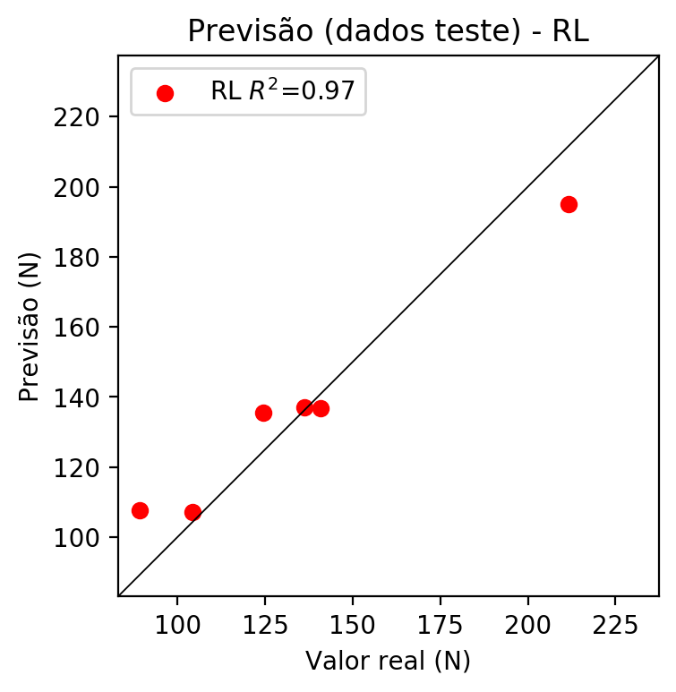

**Dados de treino**

* Erro relativo médio: 9.19
* Coeficiente de correlação: 0.92
* Coeficiente de determinação: 0.84
* MSE: 224.33
* RMSE: 14.98

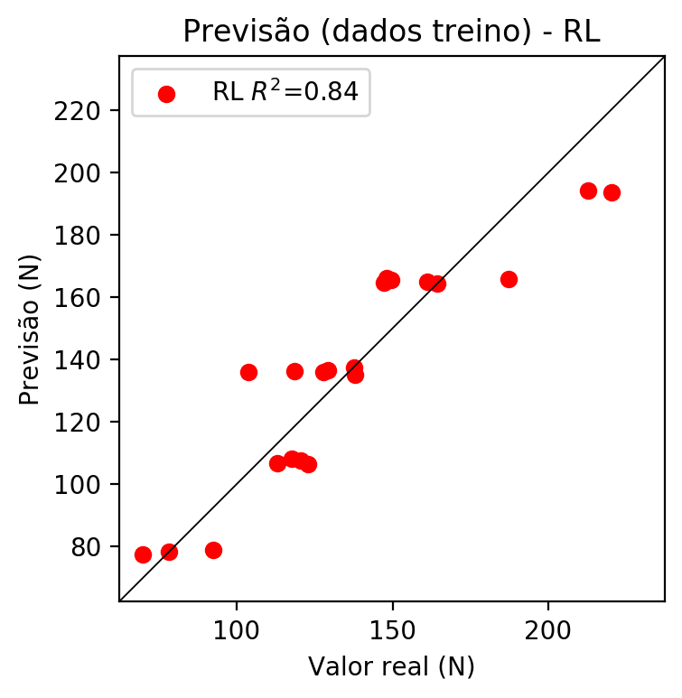

# RP2

# Coeficientes

[ 0. -0.02603229 0.66839183 0.66197741 0.19236628 -0.02467074  
 0.04344975 -0.10498437 0.19595942 0.23262664]

# Erros

**Dados de teste**

* Erro relativo médio: 8.26
* Coeficiente de correlação: 0.96
* Coeficiente de determinação: 0.92
* MSE: 153.22
* RMSE: 12.38

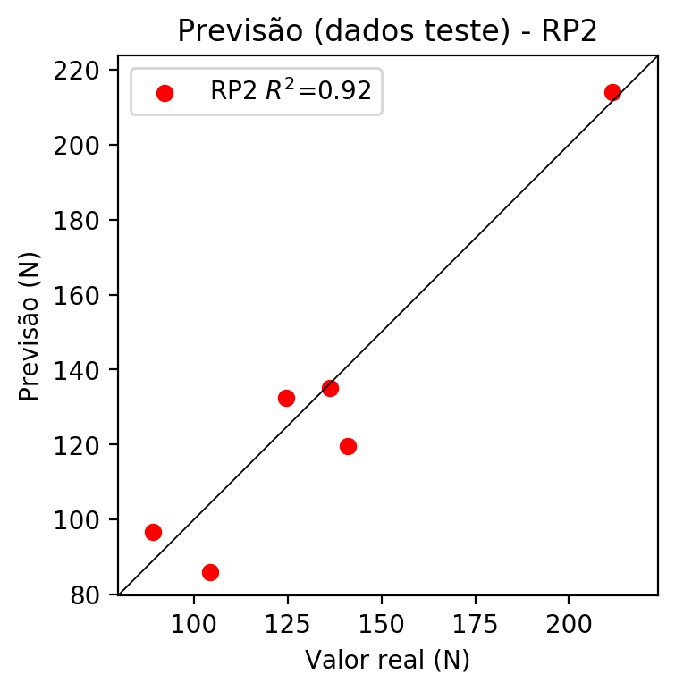

**Dados de treino**

* Erro relativo médio: 6.34
* Coeficiente de correlação: 0.96
* Coeficiente de determinação: 0.92
* MSE: 109.77
* RMSE: 10.48

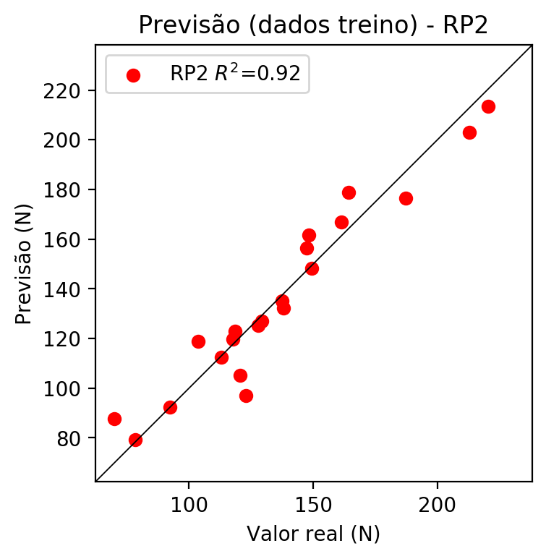

# RP3

# Coeficientes

[ 0. 0.03347457 0.16996156 0.12367372 0.1633995 -0.07349279  
 -0.01609662 -0.01270296 0.21872144 0.2708346 0.04835215 -0.09468642  
 0.2049486 -0.00379214 -0.10273154 -0.17407555 0.24550003 0.1050385  
 0.30169313 0.17863982]

# Erros

**Dados de teste**

* Erro relativo médio: 10.36
* Coeficiente de correlação: 0.97
* Coeficiente de determinação: 0.94
* MSE: 382.45
* RMSE: 19.56

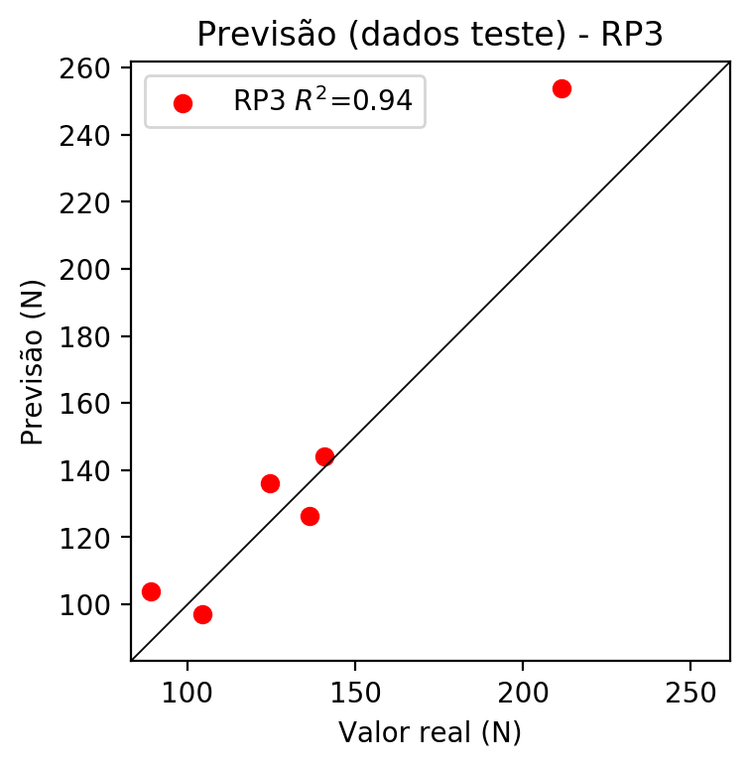

**Dados de treino**

* Erro relativo médio: 1.9
* Coeficiente de correlação: 1.0
* Coeficiente de determinação: 0.99
* MSE: 9.77
* RMSE: 3.13

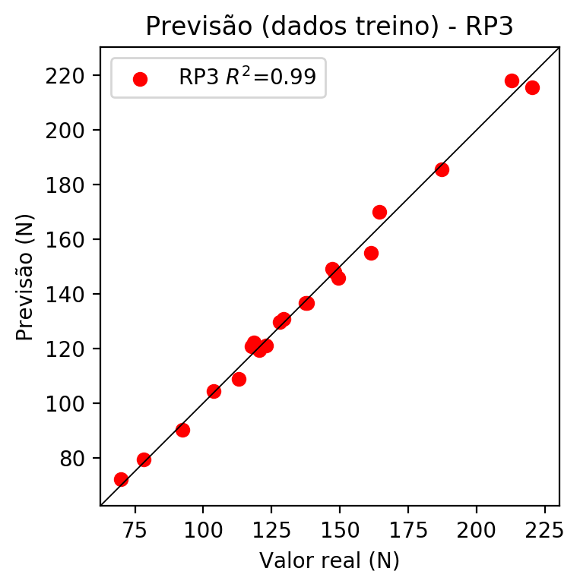

# RP4

# Coeficientes

[ 0. -0.00172032 0.17635907 0.14192353 0.02036728 -0.01618052  
 -0.01564772 0.03275341 0.04148443 0.12967893 -0.00248491 -0.12695203  
 0.14645562 0.06639694 -0.03254246 -0.0988728 0.25474087 0.06409591  
 0.2568908 0.20500065 0.0294194 -0.02337186 -0.02260226 0.03988138  
 -0.04681147 0.01387995 -0.02337186 0.12574144 0.07108565 -0.02260226  
 0.04731048 0.05992195 -0.16040698 0.05992195 0.18731401]

# Erros

**Dados de teste**

* Erro relativo médio: 6.49
* Coeficiente de correlação: 0.97
* Coeficiente de determinação: 0.94
* MSE: 85.56
* RMSE: 9.25

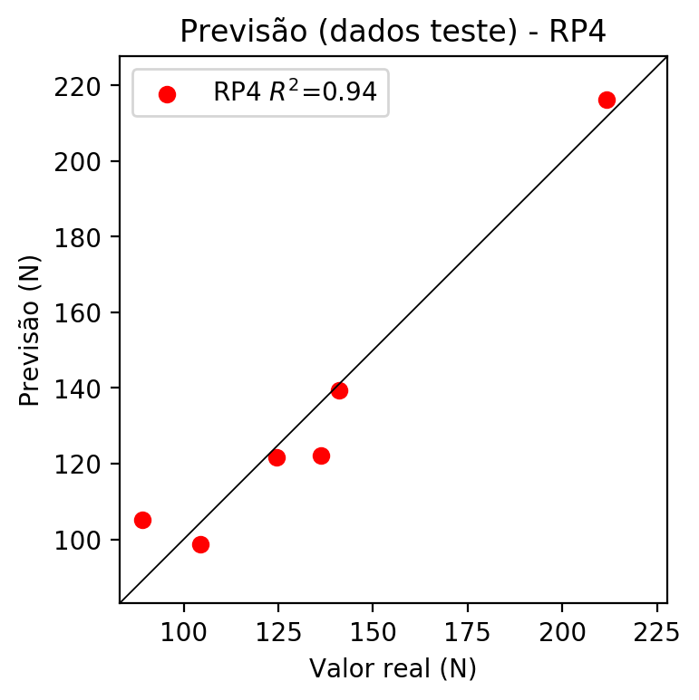

**Dados de treino**

* Erro relativo médio: 0.0
* Coeficiente de correlação: 1.0
* Coeficiente de determinação: 1.0
* MSE: 0.0
* RMSE: 0.0

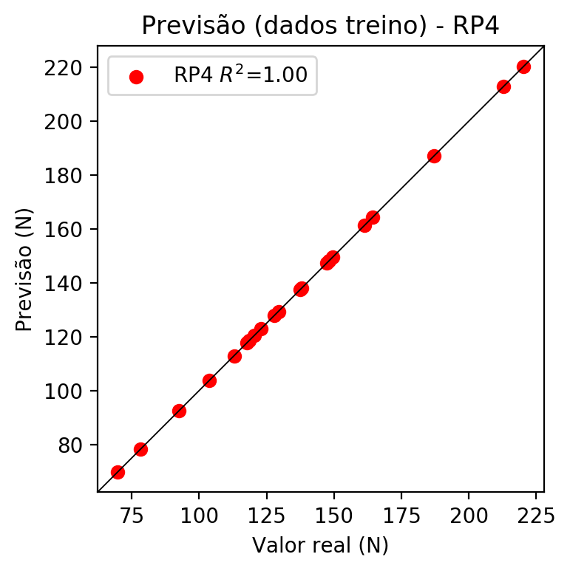

# Geral

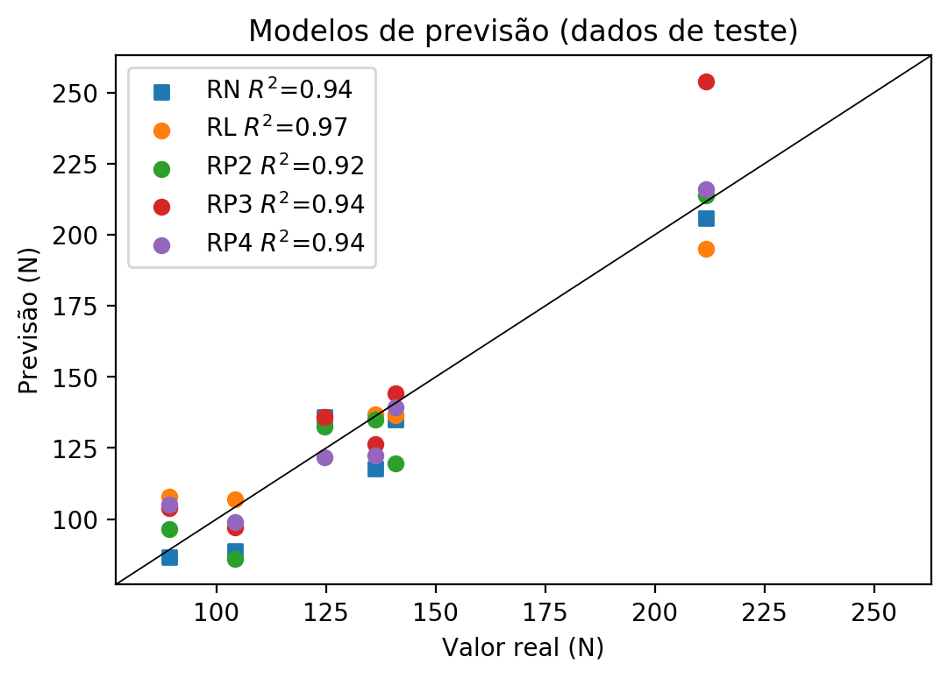

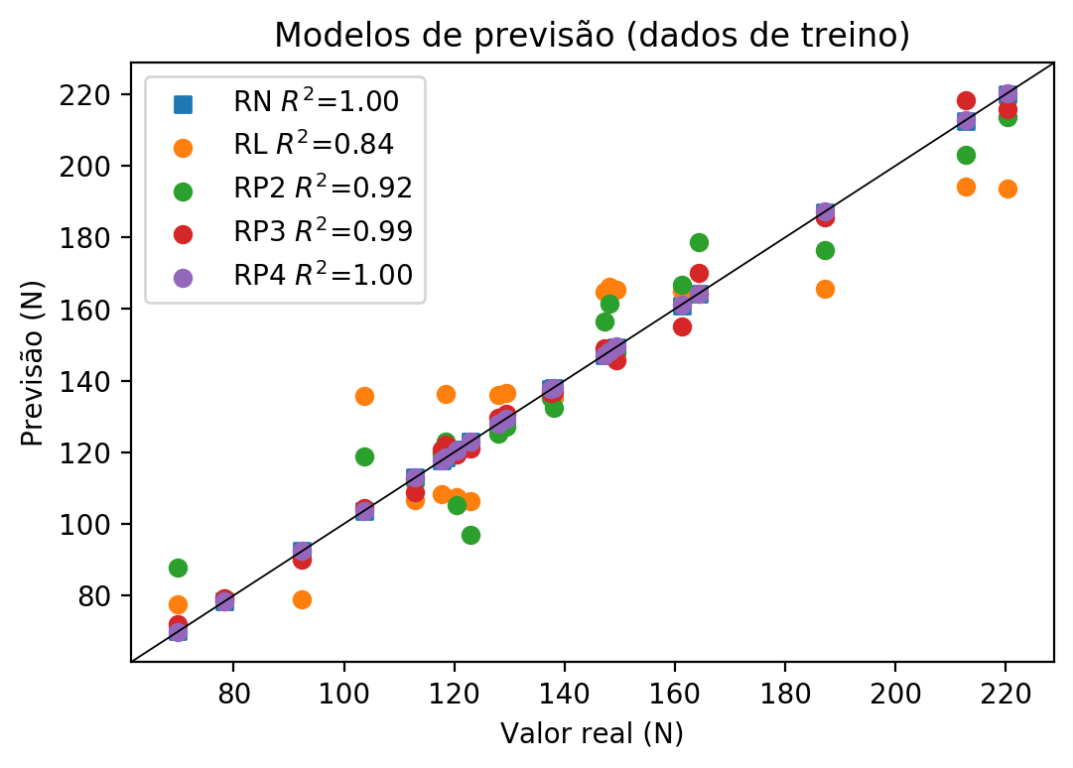

**Dados de teste**

|  |  |  |  |  |  |  |  |  |  |  |
| --- | --- | --- | --- | --- | --- | --- | --- | --- | --- | --- |
| Valor real | RN Previsto | RN Erro (%) | RL Previsto | RL Erro (%) | RP2 Previsto | RP2 Erro (%) | RP3 Previsto | RP3 Erro (%) | RP4 Previsto | RP4 Erro (%) |
| 89.16 | 86.58 | 2.89 | 107.77 | 20.87 | 96.65 | 8.4 | 103.85 | 16.48 | 105.19 | 17.98 |
| 211.59 | 205.98 | 2.65 | 194.98 | 7.85 | 213.91 | 1.1 | 253.86 | 19.98 | 216.13 | 2.15 |
| 136.24 | 117.7 | 13.61 | 136.98 | 0.54 | 134.99 | 0.92 | 126.45 | 7.19 | 122.25 | 10.27 |
| 140.93 | 134.89 | 4.29 | 136.68 | 3.02 | 119.5 | 15.21 | 144.18 | 2.31 | 139.46 | 1.04 |
| 104.31 | 88.73 | 14.94 | 107.05 | 2.63 | 86.07 | 17.49 | 97.01 | 7.0 | 98.82 | 5.26 |
| 124.55 | 136.03 | 9.22 | 135.54 | 8.82 | 132.57 | 6.44 | 136.06 | 9.24 | 121.76 | 2.24 |

**Dados de treino**

|  |  |  |  |  |  |  |  |  |  |  |
| --- | --- | --- | --- | --- | --- | --- | --- | --- | --- | --- |
| Valor real | RN Previsto | RN Erro (%) | RL Previsto | RL Erro (%) | RP2 Previsto | RP2 Erro (%) | RP3 Previsto | RP3 Erro (%) | RP4 Previsto | RP4 Erro (%) |
| 187.13 | 186.9 | 0.12 | 165.77 | 11.41 | 176.36 | 5.76 | 185.71 | 0.76 | 187.13 | 0.0 |
| 129.35 | 129.15 | 0.15 | 136.56 | 5.57 | 127.06 | 1.77 | 130.77 | 1.1 | 129.35 | 0.0 |
| 148.13 | 148.03 | 0.07 | 166.19 | 12.19 | 161.59 | 9.09 | 148.14 | 0.01 | 148.13 | 0.0 |
| 149.46 | 149.38 | 0.05 | 165.47 | 10.71 | 148.25 | 0.81 | 145.81 | 2.44 | 149.46 | 0.0 |
| 138.0 | 137.93 | 0.05 | 135.11 | 2.09 | 132.26 | 4.16 | 136.7 | 0.94 | 138.0 | 0.0 |
| 78.3 | 78.48 | 0.23 | 78.27 | 0.04 | 79.23 | 1.19 | 79.29 | 1.26 | 78.3 | 0.0 |
| 122.98 | 123.08 | 0.08 | 106.33 | 13.54 | 96.99 | 21.13 | 121.17 | 1.47 | 122.98 | 0.0 |
| 220.28 | 220.09 | 0.09 | 193.53 | 12.14 | 213.59 | 3.04 | 215.75 | 2.06 | 220.28 | 0.0 |
| 212.82 | 212.58 | 0.11 | 194.25 | 8.73 | 203.0 | 4.61 | 218.26 | 2.56 | 212.82 | 0.0 |
| 118.49 | 118.45 | 0.03 | 136.26 | 15.0 | 123.03 | 3.83 | 122.12 | 3.06 | 118.49 | 0.0 |
| 112.92 | 113.1 | 0.16 | 106.75 | 5.46 | 112.35 | 0.5 | 108.88 | 3.58 | 112.92 | 0.0 |
| 103.67 | 103.51 | 0.15 | 135.84 | 31.03 | 118.91 | 14.7 | 104.46 | 0.76 | 103.67 | 0.0 |
| 147.2 | 147.17 | 0.02 | 164.75 | 11.92 | 156.41 | 6.26 | 149.03 | 1.24 | 147.2 | 0.0 |
| 120.49 | 120.66 | 0.14 | 107.47 | 10.81 | 105.24 | 12.66 | 119.51 | 0.81 | 120.49 | 0.0 |
| 117.65 | 117.72 | 0.06 | 108.2 | 8.03 | 119.63 | 1.68 | 120.86 | 2.73 | 117.65 | 0.0 |
| 164.3 | 164.15 | 0.09 | 164.32 | 0.01 | 178.79 | 8.82 | 170.13 | 3.55 | 164.3 | 0.0 |
| 92.37 | 92.51 | 0.15 | 78.99 | 14.49 | 92.25 | 0.13 | 90.06 | 2.5 | 92.37 | 0.0 |
| 69.76 | 69.94 | 0.26 | 77.54 | 11.15 | 87.73 | 25.76 | 71.98 | 3.18 | 69.76 | 0.0 |
| 161.24 | 160.99 | 0.16 | 165.04 | 2.36 | 166.82 | 3.46 | 155.02 | 3.86 | 161.24 | 0.0 |
| 137.54 | 137.55 | 0.01 | 137.41 | 0.09 | 135.28 | 1.64 | 136.63 | 0.66 | 137.54 | 0.0 |
| 127.92 | 128.04 | 0.09 | 135.96 | 6.29 | 125.24 | 2.1 | 129.73 | 1.41 | 127.92 | 0.0 |